PRIYADHARSHINI K S – 192511248

LCM of Two 8-bit Numbers using 8085
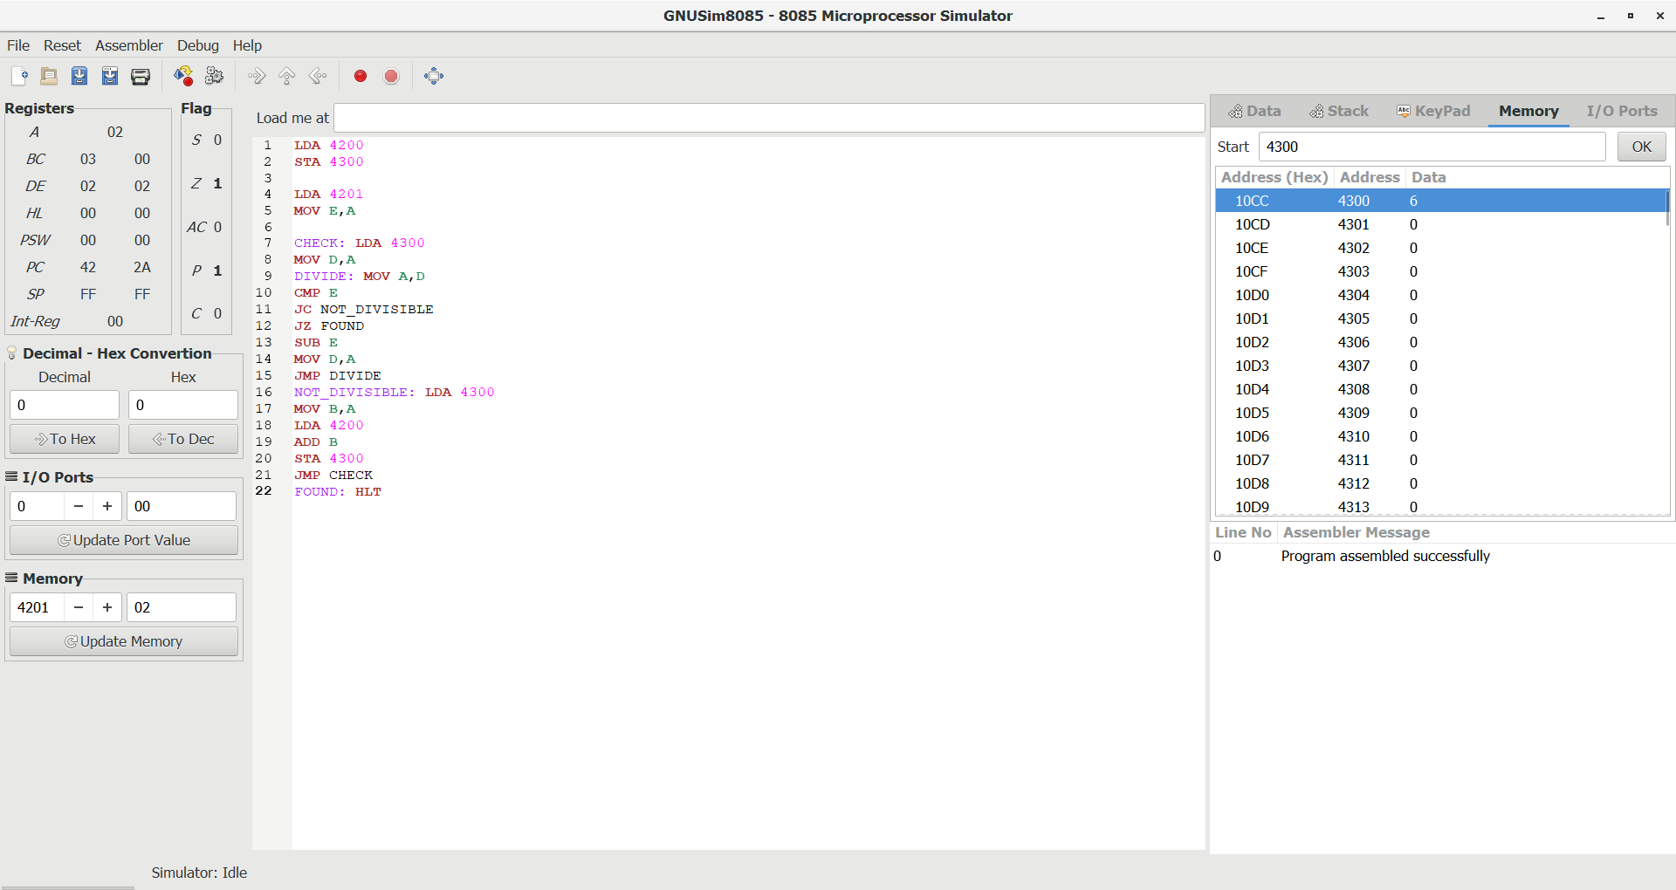

GCD of Two 8-bit Numbers using 8085
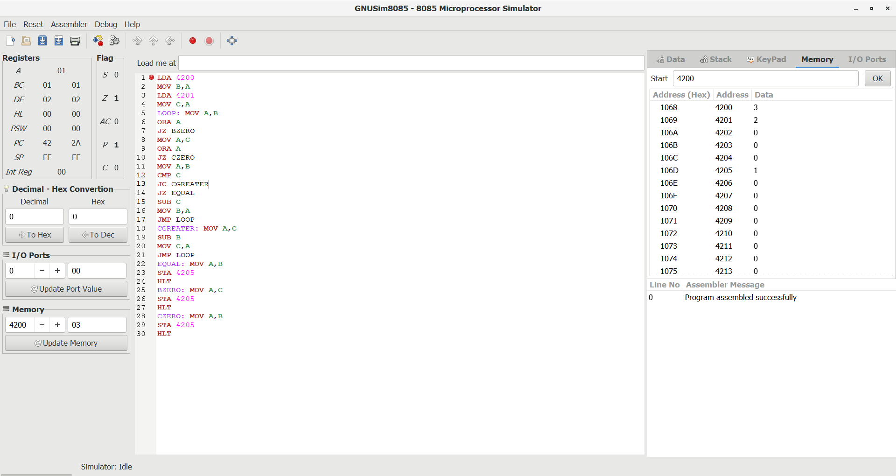

Factorial of an 8-bit Number using 8085
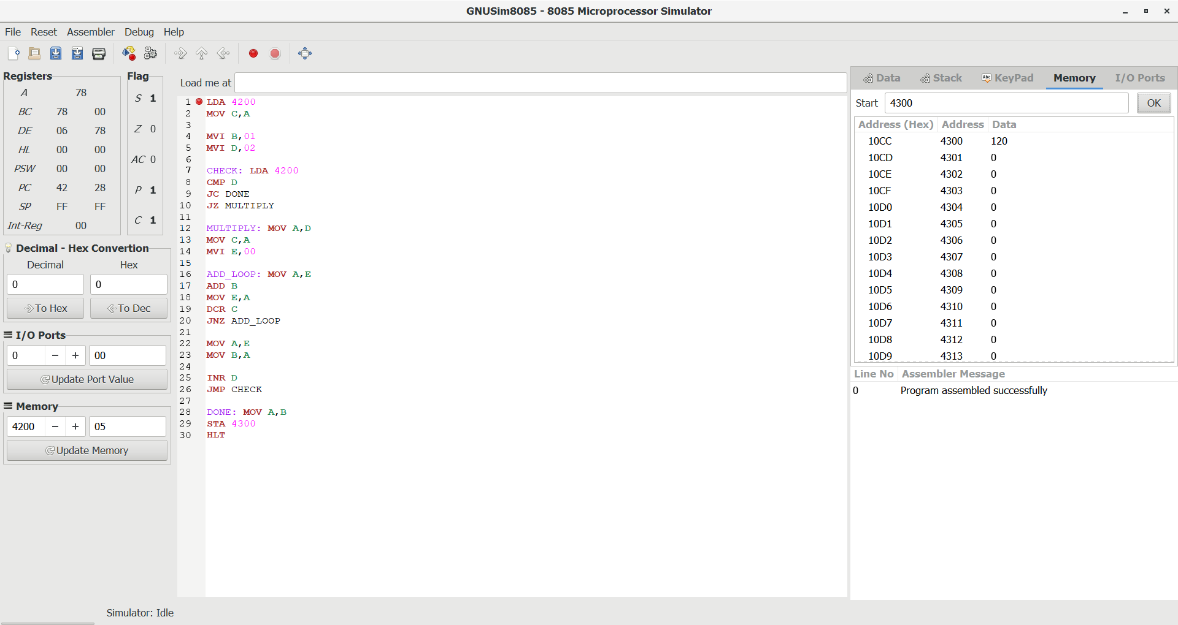

Convert decimal into hexadecimal
